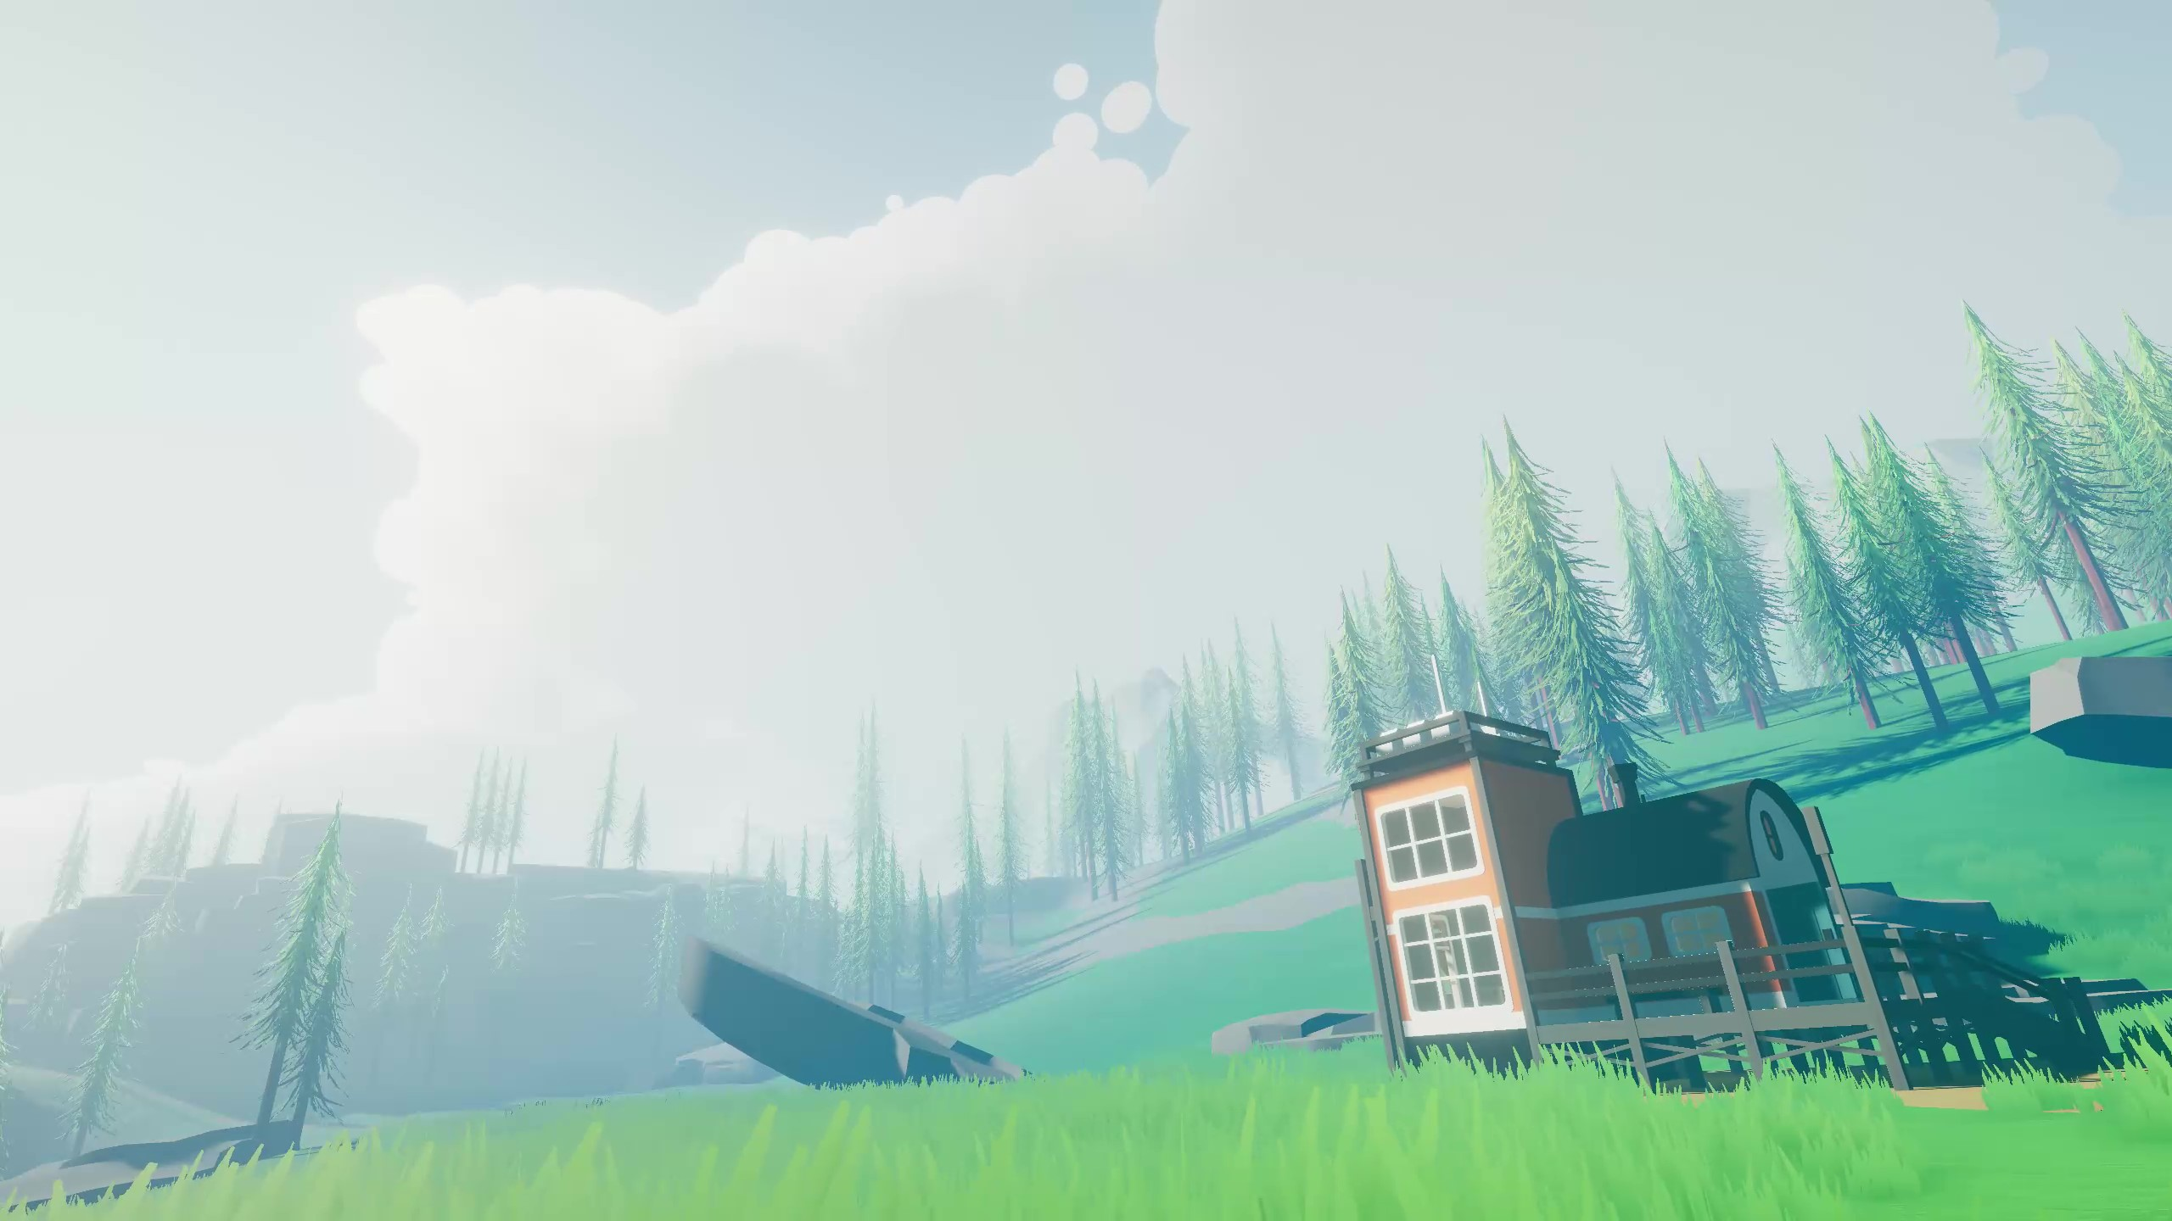

DOCUMENTATION

& USE GUIDE

**Thank you for your purchase of COZY: Weather!**

I have personally had a blast working on this project and I hope that it serves you well throughout your endeavors. I have designed Cozy to be as customizable as possible and Cozy comes with several built-in functions to help with personalization for your projects.

The purpose of this documentation is to explain all the separate functions as well as ensure proper setup. COZY: Weather is self-documented and as such most things are explained within the editor through tooltips and comments. This documentation focuses on ensuring that all the nuances of the functions are a help rather than a hinderance while you are creating your experiences. If you need any further help beyond what this documentation provides, please feel free to contact us directly. Not only will we be able to help you, but we will also be able to improve on this project through your feedback.

Best of luck as you create!

Cheers!

Keller Bowman | Distant Lands

INTRO NOTE

___________________________________________________________

Can’t find what you need here? **Get in contact with us!**

[YouTube](https://www.youtube.com/channel/UCXQh-98ACis92hNY0Qookvw)

[Website](https://distantlands.wixsite.com/distantlands)

[Discord](https://discord.gg/HWGU4hj)

[Unity Page](https://assetstore.unity.com/publishers/40676)

[E-mail](mailto:distantlands.productions@gmail.com)

***This documentation is a work-in-progress. Help us expand it by leaving***

***suggestions in our Discord server!***

GETTING STARTED

____________________________________________________________________________

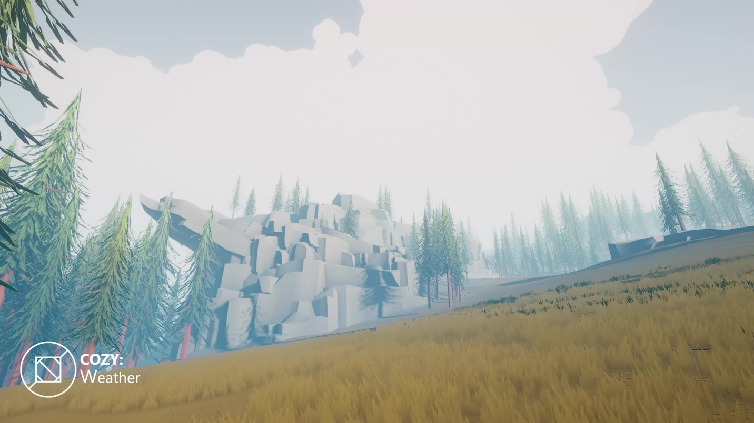

1. Setting Up Your Project

* Built-In Setup
* URP Setup
* Custom Tags, Layers, and Settings

1. Understanding The Demo Scene

* Finding the Scene
* Brief Explanations of Major Objects

1. The Cozy Editor

* Opening the Window
* Tabs and Principals

1. Setting Up a New Scene

* 3 Simple Steps
* Requirements and Limits

Next up: Under the Hood

NEW TO COZY? Don’t sweat it!

This guide should make your experience with COZY as positive as possible!

________________________________________________________

SETTING UP YOUR PROJECT

QUICK TIP: This documentation is written with a BiRP focus. Certain settings may look a bit different on URP!

____________________________________________________________________________

3. CUSTOM SETTINGS

If you plan on using the *COZY Trigger System*, we highly recommend adding the tag “FX Block Zone” to your project however you can set this to any tag you like in the *COZY Trigger Module*!

____________________________________________

2. UNIVERSAL RENDERER

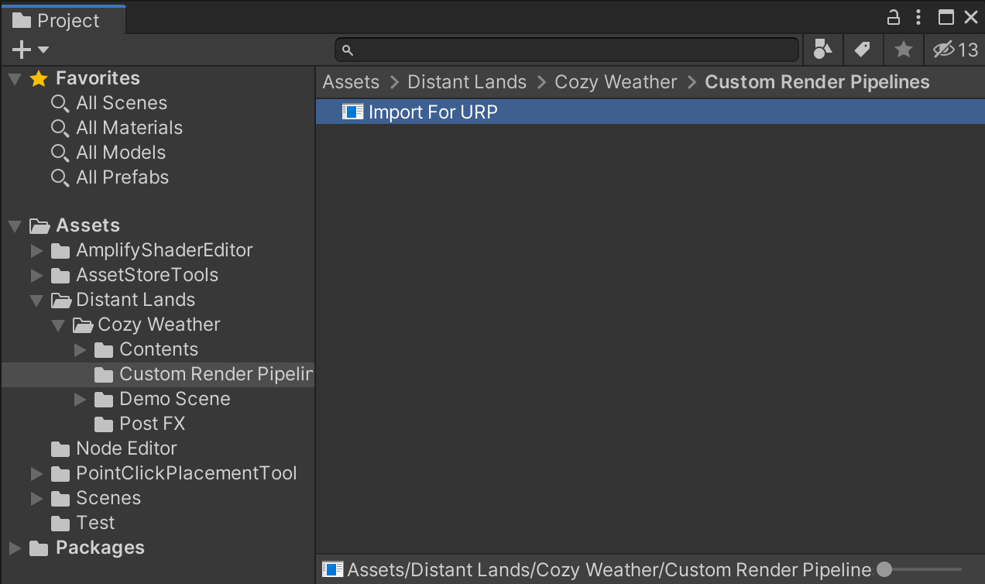

If you are running the Universal Render Pipeline, we have a separate version of COZY just for you! Import the “Import for URP package” found in the Custom Render Pipelines folder for best results.

____________________________________________

After importing, be sure to enable the depth texture in your pipeline asset!

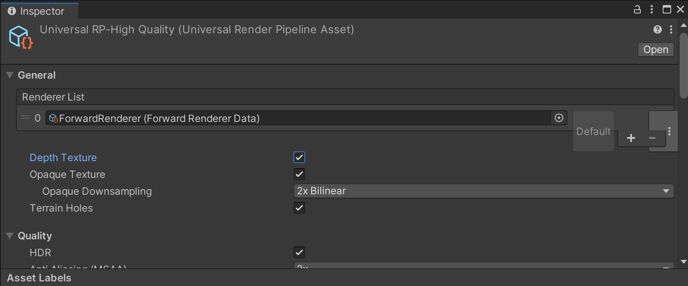

1. BUILT IN RENDERER

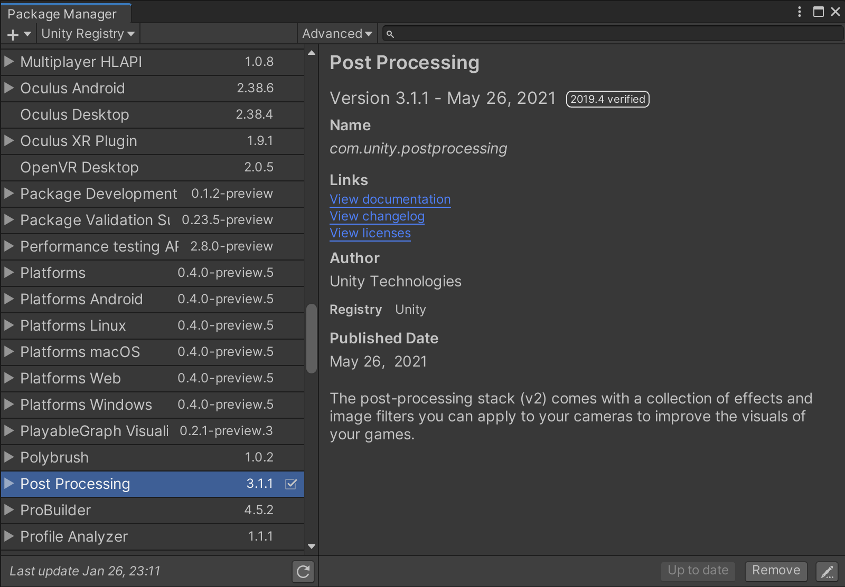

If you are running the Built-In Render Pipeline, we highly recommend importing the Post Processing package from the package manager.

____________________________________________

We also highly recommend working in the linear color space. This allows for higher color contrast and proper color placement across all your scenes—no matter the time of day!

UNDERSTANDING

THE DEMO SCENE

____________________________________________________________________________

PRESS PLAY

TO GET LOST

This scene is setup ready to work out of the box with the default COZY settings. There is a lot left to cover as far as customization goes but if you are just looking to play around and see what COZY is all about, this scene is for you!

____________________________________________

The best way to quickly get to know COZY, is through the demo scene. Start by opening the demo scene found at Distant Lands/Cozy/Demo Scene/Observation Plains.

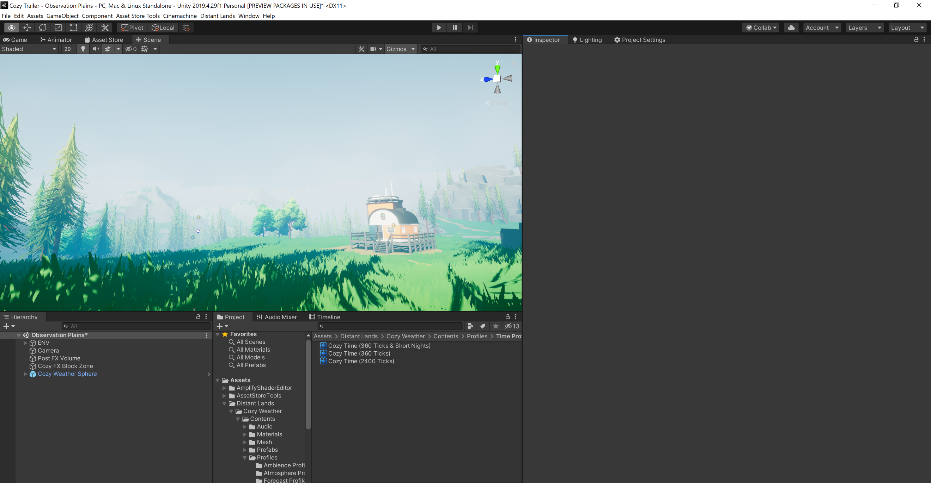

It’s important to take note of a few objects in the scene:

1.

2.

3.

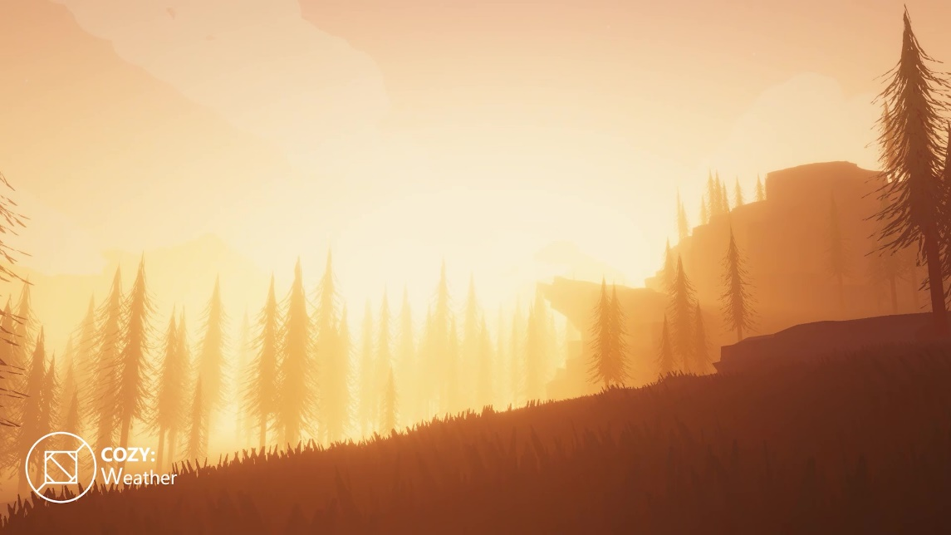

The ENV object stores all the demo meshes in the scene. This includes trees, terrain, rocks, and grass.

The Main Camera functions as the main viewport for the scene. COZY requires a main camera to function properly!

The Cozy Weather Sphere is the head unit for COZY. This object holds the sky, fog and clouds as well as manages all runtime changes

THE COZY EDITOR

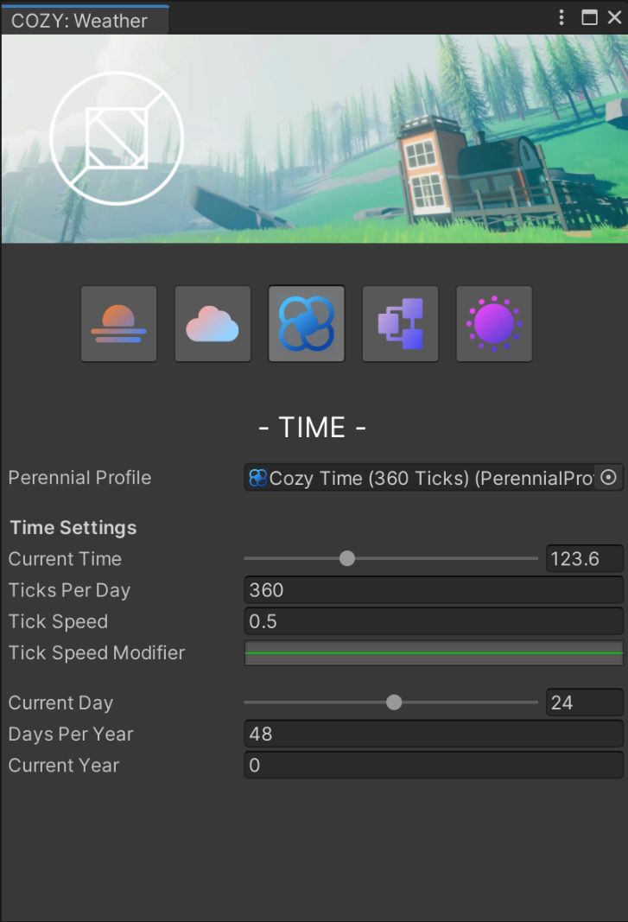____________________________________________________________________________

COZY is now controlled through a centralized window system known as the COZY editor. Open the COZY editor through the menu item found at Distant Lands/Cozy/Open Cozy Editor!

The COZY Editor separates all the settings into 5 main tabs. Let’s run through them now!











The *Atmosphere* tab controls all settings that relate to the atmosphere. Celestials, skybox colors, stars, and lighting are all controlled under this tab!

The *Fog and Clouds* tab controls all settings that relate to airborne water. Control cloud and fog colors, cloud shapes and more here!

The *Time* tab controls all settings that relate to time passing. Control the current day and time and how fast time moves.

The *Modules* tab controls the modules used by the current COZY system. See the documentation on modules for more information!

QUICK TIP: Does your window not look like this when you open it? See new scene setup instructions on the next page!

The *Settings* tab controls the main settings for COZY. Change the quality settings, save and load, and more!

SETTING UP A SCENE

____________________________________________________________________________

COZY makes setting up a new scene incredibly easy! All you have to do is

follow 3 quick steps:

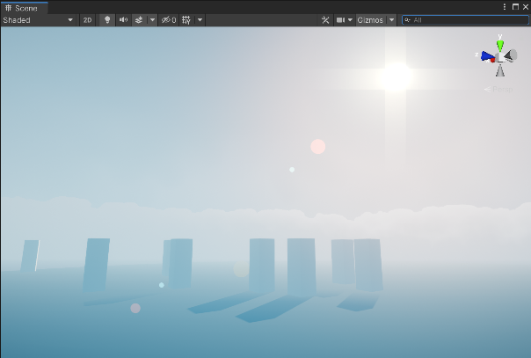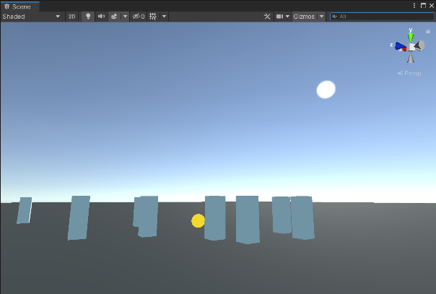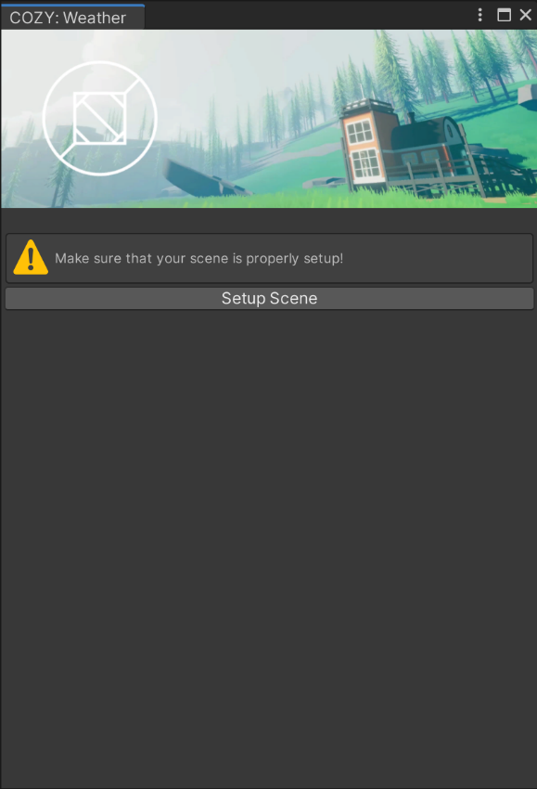

1. OPEN THE COZY EDITOR

Start by opening the COZY Editor in a scene that does not have an active COZY system already

____________________________________________

3. PRESS PLAY

And you’re done! Use the COZY editor to change parameters as you need.

By default, the COZY system will start up with all modules enabled and in desktop mode.

____________________________________________

2. CLICK SETUP SCENE

The window looks a bit different in an empty scene! All the tabs are gone and in their place is a big button that you should click right now.

____________________________________________

Note: you do need to have an active main camera for this step to work!

UNDER THE HOOD

____________________________________________________________________________

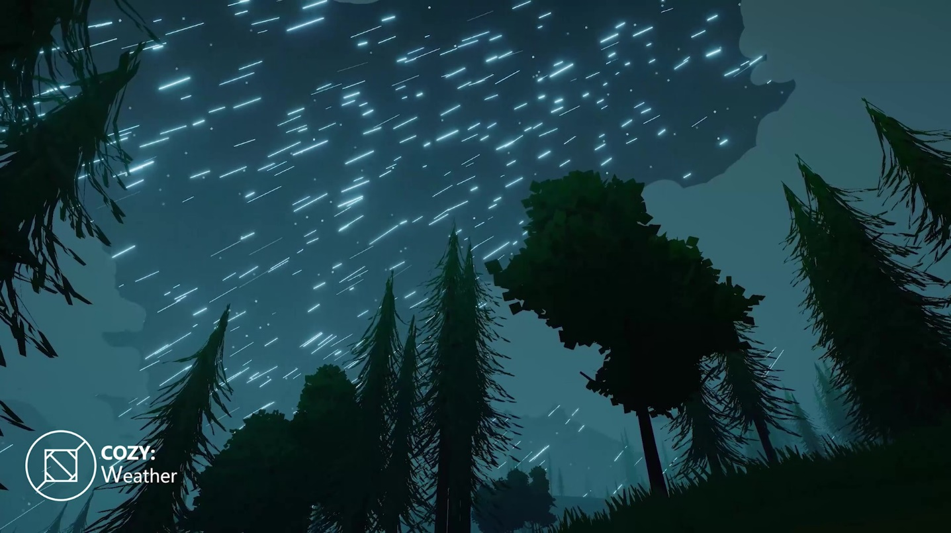

1. Introduction to Profiles

* What is a *Profile*?
* Using *Profiles* with COZY

1. Introduction to Modules

* What is a *Module*?
* Modules & Performance

1. The Sky

* Skydome vs Skybox

1. The Clouds

* Intro to the Shader
* The Main Noise Functions

1. The Fog

* What is multi-layer fog?
* Technical Terms and Jargon

Next up: Making it Yours

WONDER HOW IT WORKS?

This section of the documentation touches on a few details for the individual rendering components that COZY uses.

________________________________________________________

INTRODUCTION TO PROFILES

QUICK TIP: Not all profiles are used by the main system. If you aren’t running any *modules,* you only need to use the Perennial, Weather, and Atmosphere Profiles!

____________________________________________________________________________

during prototyping without overriding the COZY: Weather game object.

COZY uses a network of scriptable objects we call profiles to control all the parameters at runtime. Check out the various profiles and what they do here! This allows you to easily save and load snapshots, make global changes during play mode, and safely save old versions

AMBIENCE PROFILE

Manages the particles, SFX and forecast patterns for an individual ambience.

ATMOSPHERE PROFILE

Manages the references for colors of lights, the skybox, fog, and clouds.



CLIMATE PROFILE

Manages the temperature and precipitation amount curves.

MATERIAL MANAGER PROFILE

References the materials that will change throughout the year.



WEATHER PROFILE

Manages settings for an individual weather pattern such as cloudy, sunny, heavy rain, etc.









AMBIENCE FORECAST PROFILE

Manages the Ambience Profiles that the COZY Ambience Module will play at runtime.

FORECAST PROFILE

Holds the references to every Weather Profile that the COZY Forecast Module will play.



PERENNIAL PROFILE

Manages all time related properties for COZY.



INTRODUCTION TO MODULES

____________________________________________________________________________

very interesting performance metrics. For example, if in your project you handle the weather changing manually, simply delete the forecast module and take full control! This not only gives you ultimate customizability, but also removes a thread from your update loop!

Not all Unity projects are built the same and COZY is built to honor that! COZY runs using a series of *modules* or scripts on a single object that modify the code that runs. This not only allows you to quickly debug and experiment with individual features, but also gives rise to

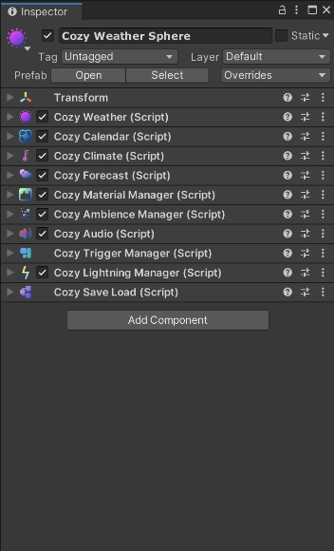

COZY MATERIAL MANAGER

Allows materials outside of the COZY system to be affected e.g., snow, changing foliage colors, etc.

COZY WEATHER

The main module for COZY. This is the backbone of the COZY system and required for any project.

COZY AUDIO

Manages all the sound FX you hear at runtime.



COZY TRIGGER SYSTEM

Don’t want weather to appear in buildings? Use this system to setup interiors!







COZY SAVE LOAD

Easily save and load the current weather system to keep all properties even after quitting a game!





COZY LIGHTNING MANAGER

Does what it says! Manages the instantiation and destruction of lightning objects at runtime.







COZY FORECAST

Changes the active Weather Profile at runtime in an intelligent way.



COZY CLIMATE

Changes the temperature and precipitation. Use with the Forecast Module for better forecasting.

COZY AMBIENCE MANAGER

Manages the secondary ambience system. For more information, check out the API documentation!

COZY CALENDAR

Manages the changing of time and date during runtime.

THE SKY

____________________________________________________________________________



COZY’s sky dome is made up of 3 major sections: the main sky, the clouds, and the fog. Each of these sections have multiple subgroups that affect the way that the whole is interpreted.

_________________________________________________________________

The first subgroup of the main sky is a simple gradient shader that interpolates between the zenith and horizon of the sky. This is modified by the atmosphere variation property to create a more varied and visually interesting sky.

_________________________________________________________________

The next subgroup dictates celestial parameters or put more clearly, settings for the sun. Change the direction, color, size, and falloff of the sun here!

_________________________________________________________________

The last major subgroup deals with other light FX. Star colors, galaxies, light columns, and more are managed here. All of the FX are additive so if you would like to disable any of them, simply set their color to black and they will disappear!





THE CLOUDS

CUMULUS CLOUDS

The default clouds for COZY. Big, fluffy, Voronoi noise patterns that lead to stylish skies!

____________________________________________________________________________

The next section of COZY’s sky dome is the cloud sphere. This is one of the most distinctive sections of COZY that separates it from other weather systems. COZY ships with 7 different cloud algorithms that all combine to make a varied and stylish sky!



CIRRUS CLOUDS

Windswept stylish clouds that can add a touch of flavor to otherwise clear skies

NIMBUS CLOUDS

Amends the cumulus algorithm allowing storms to envelope your world giving players a sense of warning

CHEMTRAILS

Staples of anime style skies, the chemtrails algorithm emulates the moisture left by jet trails.

CIRROSTRATUS CLOUDS

Noisy high-altitude clouds that signify cold temperatures, low humidity and heavy wind.



BORDER CLOUDS

Set your scene with a ring of clouds around the horizon! Set the effect in the negatives to remove clouds rather than add them!

ALTOCUMULUS CLOUDS

Super high-altitude clouds that can add a touch of detail to your scene.

THE FOG

QUICK TIP: This style of fog shader is inspired by several influential games such as Firewatch and Among Trees. For more ideas and use cases, check out their results!

____________________________________________________________________________



The fog dome is the true hero of COZY: Weather and provides most of the color dynamic and atmosphere.

The fog dome is a combination effort between a traditional false height fog, a sunlight flare halo, and a gradient-based stylized linear fog.

The height-based portion fades the fog into the sky creating an illusion of a large atmosphere. The smoothness, intensity and offset of the fog can be tweaked to create different atmosphere types.

The sun flare provides a ton of atmosphere by additively changing the color of the fog in the direction of the sun. This effect simulates certain aspects of volumetric fog at half the performance cost!

The linear stylized fog is a simple gradient composed of 5 colors (alpha controls density) that are controlled by the COZY head unit. Instead of mathematically calculating the most realistic fog parameters, COZY passes the depth into the gradient to come up with a color and density to render on a per-pixel basis.

This gradient allows you to easily have layers of color that all pop but still co-ordinate with each other. For example, while the fog in the background of the scene is a vibrant orange, the fog on the trees in the foreground are a deep purple

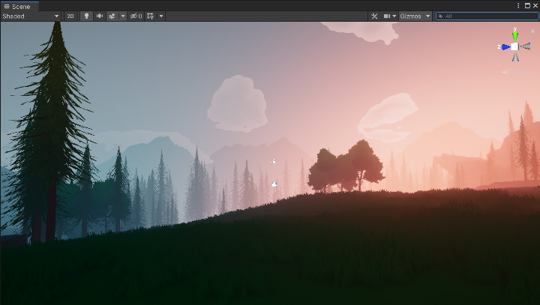

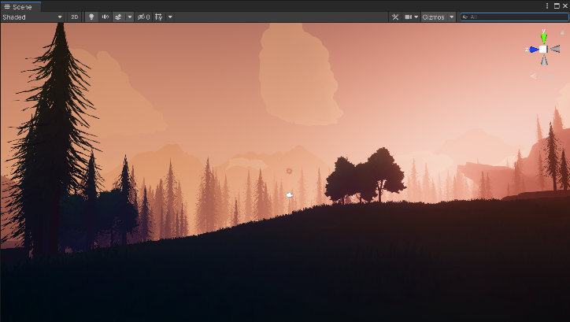

INTEGRATIONS

____________________________________________________________________________

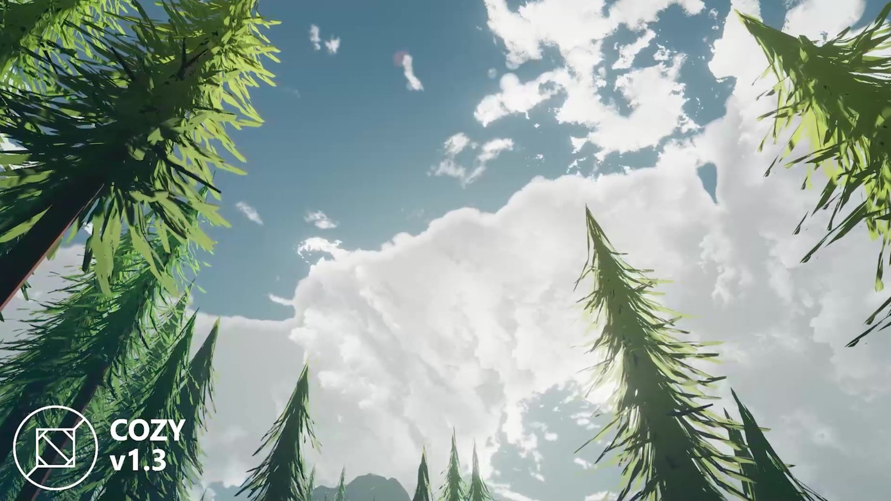

1. Water Integrations

* Crest Ocean
* Stylized Water 2

1. Script Integrations

* The Vegetation Engine

Next up: Coming Soon

EVERY PROJECT IS UNIQUE

COZY ships with many tools to help you with integrations and customization. Let us do the heavy lifting when it comes to making your project work so that you can have infinite freedom to explore your weather system!

________________________________________________________

CREST INTEGRATION

____________________________________________________________________________

Follow these simple steps for Crest Ocean support with COZY: Weather! Note that these steps only work in v1.4+

To start the integration, open the Ocean.shader file. Then find the blue line and add the yellow code.

Cull [_CullMode]  
**Stencil  
{  
     Ref 222 //Set to 221 in URP  
     Comp Always  
     Pass Replace  
}**

____________________________________________

#include "Lighting.cginc"  
**#include "Assets/Distant Lands/Cozy Weather/Contents/Materials/Shaders/Includes/StylizedFogIncludes.cginc"**

____________________________________________

BiRP

if (!underwater)  
{

     //UNITY_APPLY_FOG(input.fogCoord, col); **col = BlendStylizedFog(input.worldPos, half4(col.xyz, 1));**  
}

URP

if (!underwater)  
{

     //UNITY_APPLY_FOG(input.fogCoord, col); **col = BlendStylizedFog(input.positionWS_fogFactor, half4(col.xyz, 1));**  
}

STYLIZED WATER 2

INTEGRATION

____________________________________________________________________________

Follow these simple steps for Stylized Water 2 support with COZY: Weather! Note that these steps only work in v1.4+

To start the integration, open the StylizedWater2.shader file. Then find the blue line and add the yellow code.

Cull [_Cull]  
**Stencil  
{  
     Ref 221  
     Comp Always  
     Pass Replace  
}**

____________________________________________

#include "Libraries/Lighting.hlsl"  
**#include "Assets/Distant Lands/Cozy Weather/Contents/Materials/Shaders/Includes/StylizedFogIncludes.cginc"**

____________________________________________

Now open the ForwardPass.hlsl file. Then find the blue line and add the yellow code.

**ApplyFog(finalColor.rgb, input.fogFactorAndVertexLight.x, ScreenPos, wPos, vFace);**

**finalColor = BlendStylizedFog(wPos, finalColor);**

THE VEGETATION ENGINE

____________________________________________________________________________

COZY comes with TVE integration out of the box; all you have to do is add the module to your system and you are good to go! First setup your scene for TVE and for COZY and then follow these two steps to allow COZY to take control of your TVE objects.

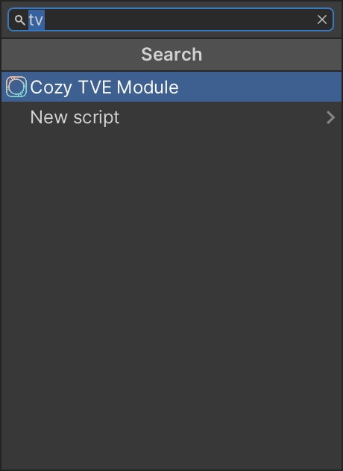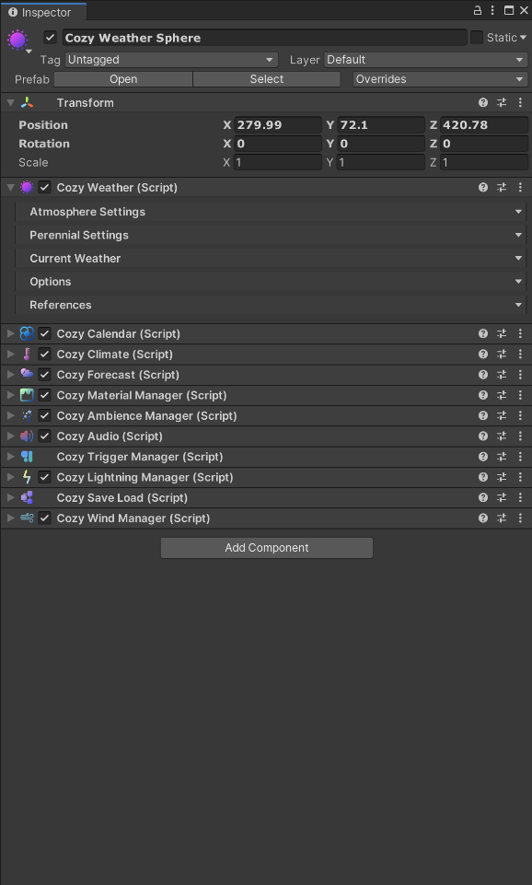

2. ADD THE TVE MODULE

Now search for the Cozy TVE Module and add it to your system. This module sends all of COZY’s information to The Vegetation Engine.

____________________________________________

1. SELECT THE COZY SYSTEM

Select your COZY system in the scene view. Next scroll all the way to the bottom of the inspector and hit the add component button.

____________________________________________

Note: setup your TVE scene first!

THIS DOCUMENT IS WORK IN PROGRESS

We plan on expanding this documentation in the near future however extenuating circumstances have

made that more difficult than we initially realized. Next on the to-do list is customization and API docs.

Thanks for your patience!